Module 03
Aim : Implement Infrastructure as a Service
Objective: Implement IaaS using your resources.

Technology: Open Stack

Theory:
DevStack Minimum Requirements
- Fresh installation of Ubuntu 18.04
- Minimum memory of 4 GB
- At least 2 vCPU
- The storage capacity of 10 GB should be sufficient.
- Internet connection
- User with sudo

Step 1: Update Ubuntu system
Login to your Ubuntu system – Can be Desktop or VM in the Cloud and update it.
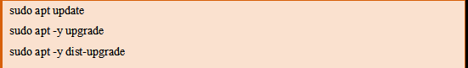
Reboot it after an upgrade.
sudo reboot

Step 2: Add Stack User
Devstack should be run as a non-root user with sudo enabled. If you’re running your instance in the cloud, standard logins to cloud images such as “centos” or “ubuntu” or “cloud-user” are usually fine.
For other installations of Ubuntu 18.04, run the commands below to create DevStack deployment user.
sudo useradd -s /bin/bash -d /opt/stack -m stack
Enable sudo privileges for this user without need for a password.
echo "stack ALL=(ALL) NOPASSWD: ALL" | sudo tee /etc/sudoers.d/stack
Switch to s stack user to test.
jmutai@devstack:~$ sudo su - stack
stack@devstack:~$ sudo su -
root@devstack:~#

Step 3: Download DevStack
Clone Destack deployment code from Github.
su - stack
sudo apt -y install git
git clone https://git.openstack.org/openstack-dev/devstack
Create a local.conf file with 4 passwords and Host IP address.
cd devstack
nano local.conf
Add:
[[local|localrc]]

# Password for KeyStone, Database, RabbitMQ and Service
ADMIN_PASSWORD=StrongAdminSecret
DATABASE_PASSWORD=$ADMIN_PASSWORD
RABBIT_PASSWORD=$ADMIN_PASSWORD
SERVICE_PASSWORD=$ADMIN_PASSWORD

# Host IP - get your Server/VM IP address from ip addr command
HOST_IP=192.168.10.100

Step 4: Start Openstack Deployment on Ubuntu 18.04 with DevStack
Now that you’ve configured the minimum required config to get started with DevStack, start the installation of Openstack.
cd devstack
./stack.sh
DevStack will install;
- Keystone – Identity Service
- Glance – Image Service
- Nova – Compute Service
- Placement – Placement API
- Cinder – Block Storage Service
- Neutron – Network Service
- Horizon – Openstack Dashboard
This will take a 15 – 20 minutes, largely depending on the speed of your internet connection. At the end of the installation process, you should see output like this:

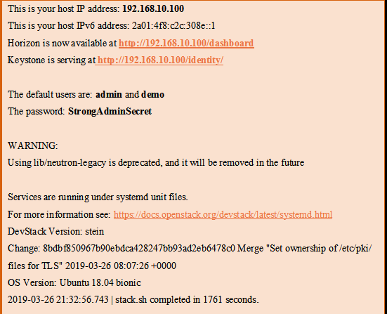

Step 5: Access OpenStack Dashboard
Copy the Horizon URL shown on the installation output and paste it into your web browser:
http://192.168.10.100/dashboard
Use the default users d demo or admin and configured password to login.
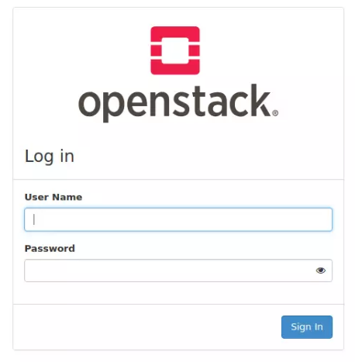
You should see Openstack Management Web console after logging in. 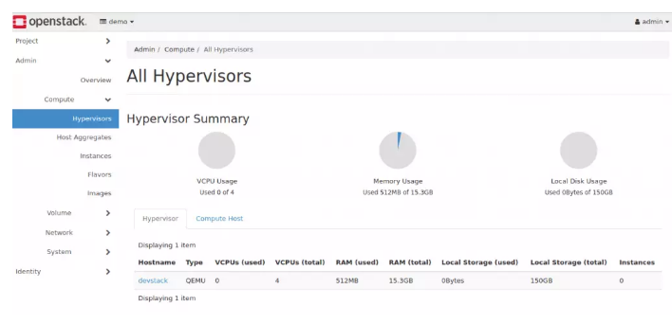
If you want to use Openstack command-line tool to manage your devstack. You’ve to source openrc in your shell.
source openrc
You can now add instance images to Glance to use when creating Virtual Machines with Nova. We have a comprehensive guide on Adding images to Openstack Glance.

Adding Cirros Test Image
Download Virtual Image.
wget http://download.cirros-cloud.net/0.4.0/cirros-0.4.0-x86_64-disk.img
Upload it to Glance.
openstack image create \
--container-format bare \
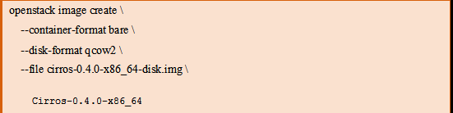
Confirm image upload.
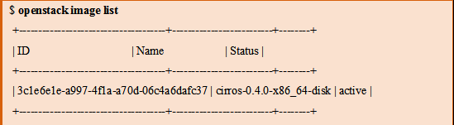
It should be visible from the Web UI 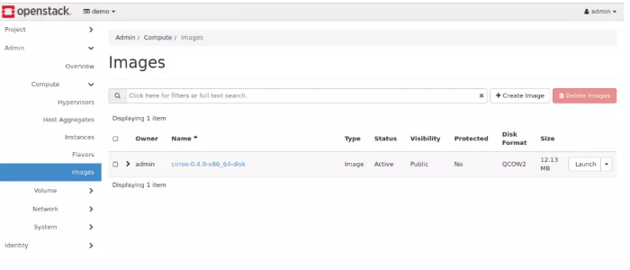
Conclusion :
OpenStack is a cloud operating system that controls large pools of compute, storage, and networking resources throughout a datacenter, all managed and provisioned through APIs with common authentication mechanisms.
Program  Execution/  formation/  correction/  ethical practices  (07) | Documentation  (02) | Punctuality  (01) | Viva Answer  (05) | Experiment  Marks (15) | Teacher Signature with date

